AZURE LOGIN THROUGH CLI:

From VS CODE:
STEP1: first clear azure account in the terminal.
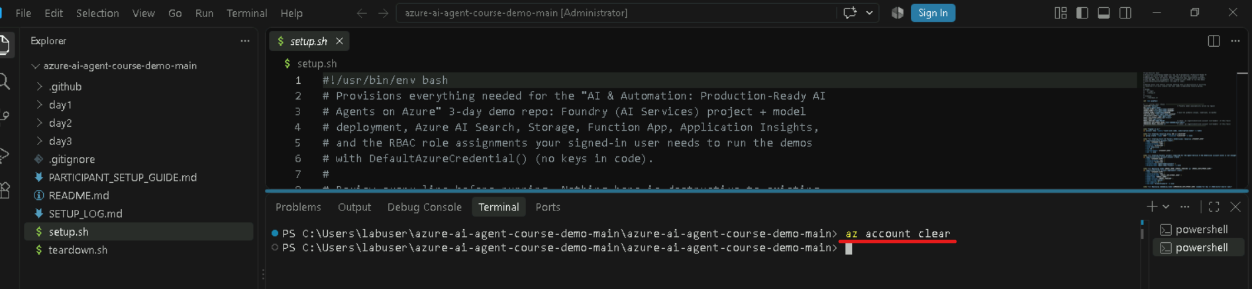

STEP2: now give this command,
az config set core.enable_broker_on_windows=false
because Azure CLI on Windows can use Web Account Manager (WAM), Microsoft's Windows authentication broker.
When this setting is true (the default in newer Azure CLI versions), az login can use WAM for authentication.
When you set: core.enable_broker_on_windows=false
you're telling Azure CLI: "Don't use the Windows authentication broker. Use the regular browser-based authentication flow instead."
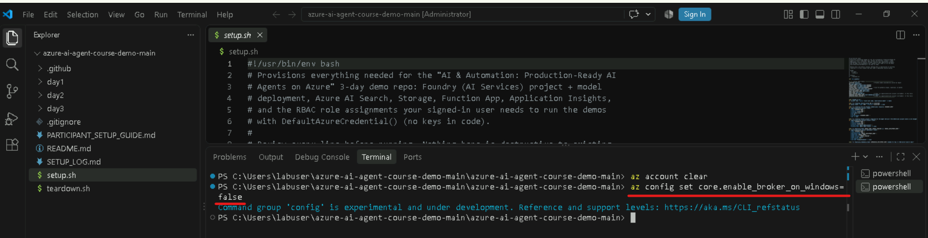

STEP3: now do login to azure account using the command:
az login
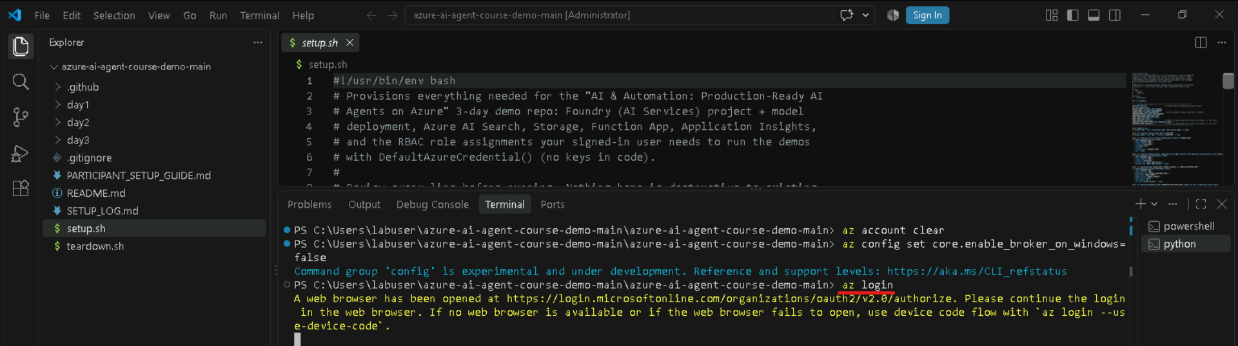

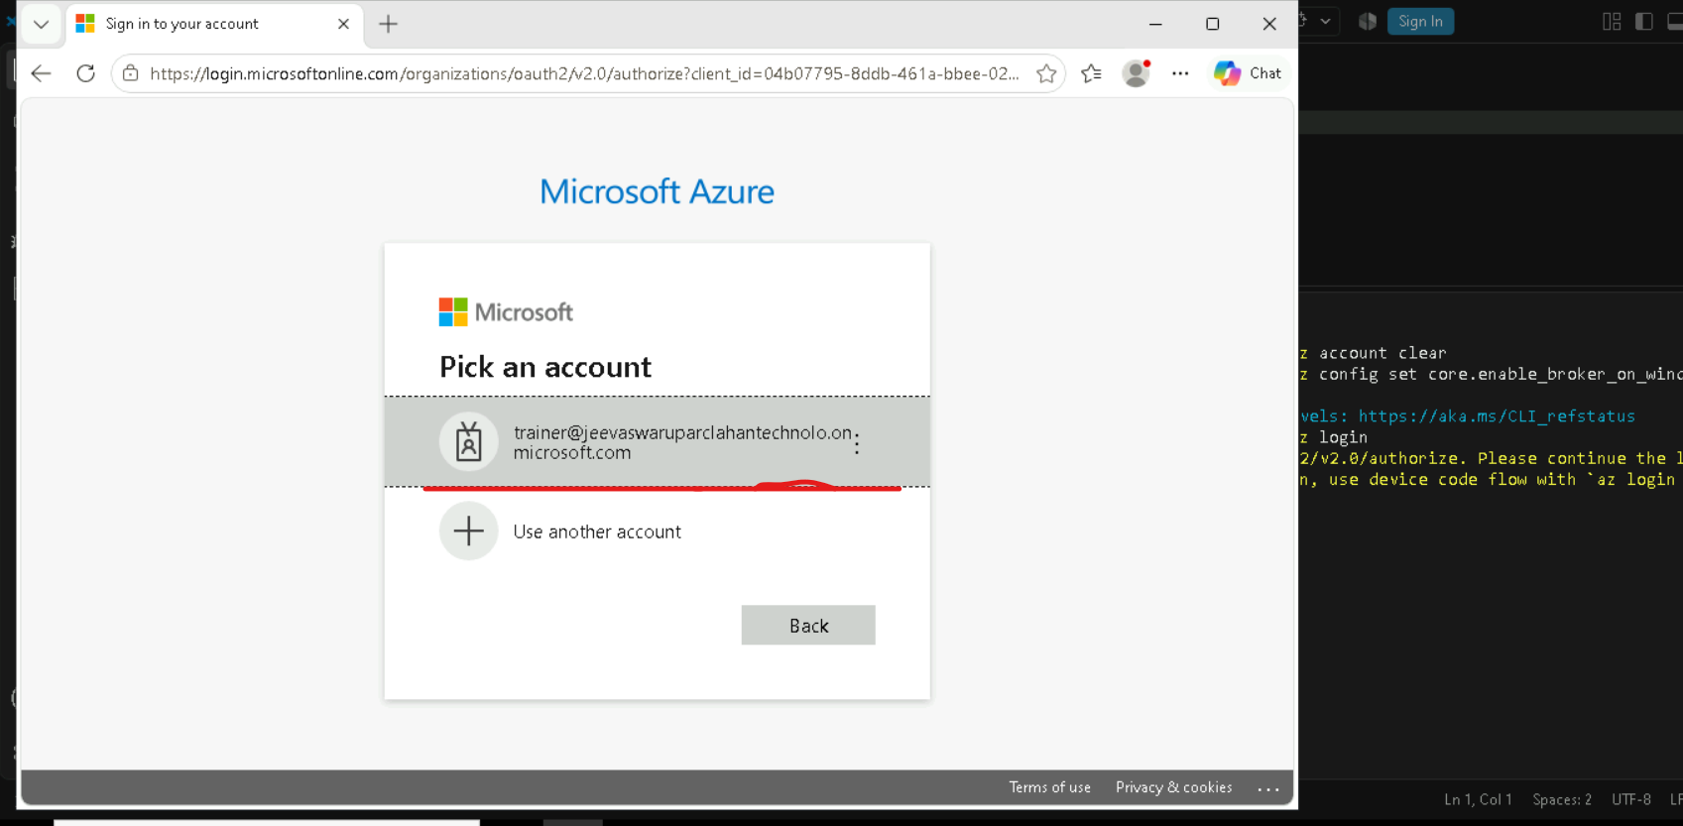
STEP4: now enter password of that trainer user.
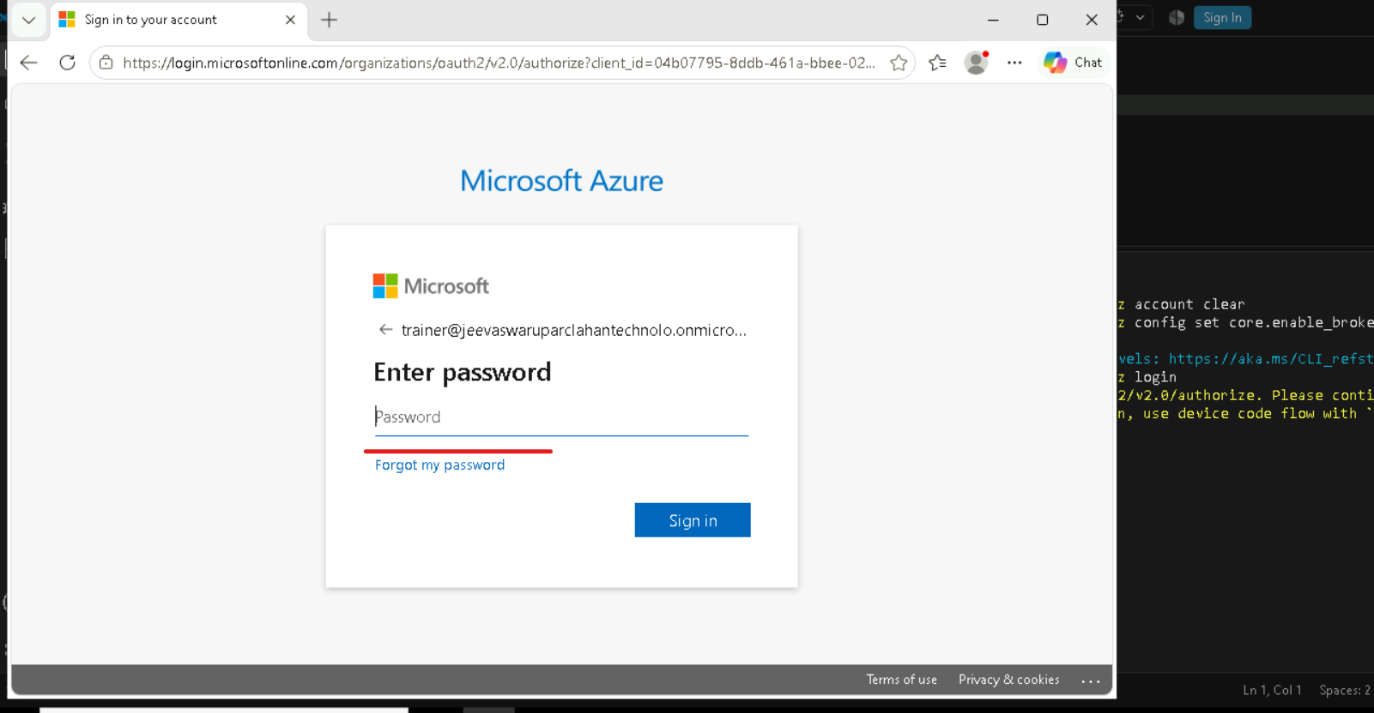

STEP5: now if u go to terminal in vs code, it will show & ask for subscription.
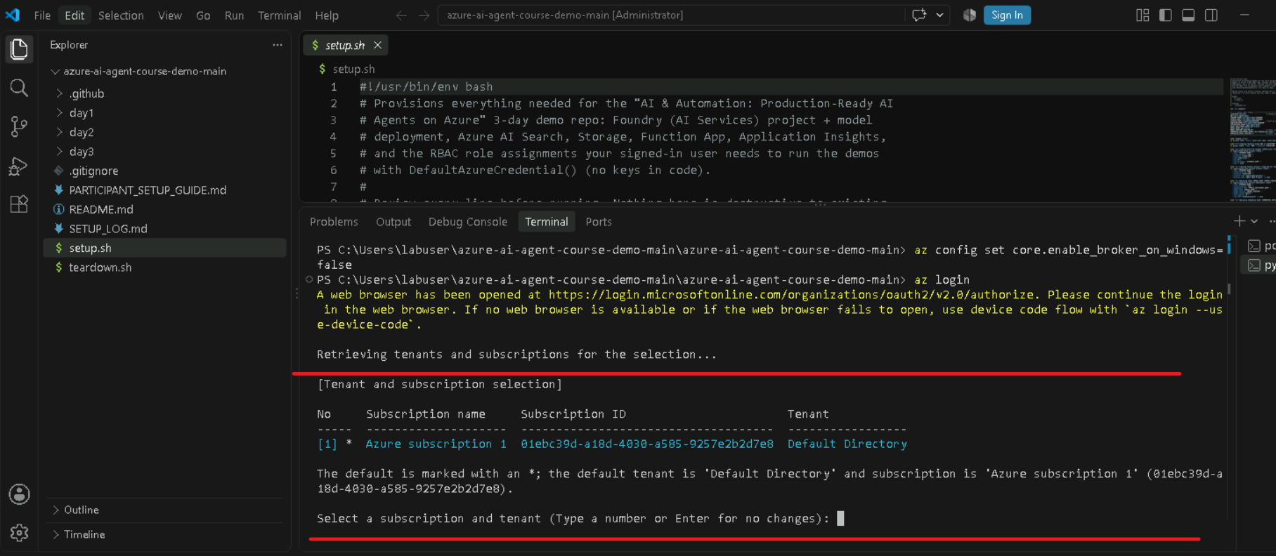
STEP6: now enter the number of subscription(1) then it is like this
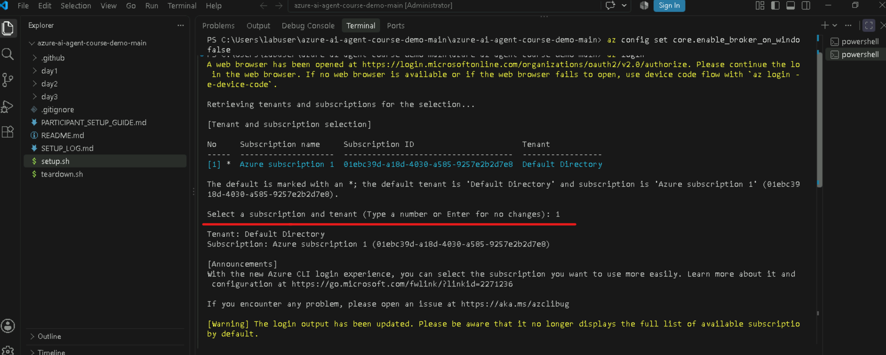

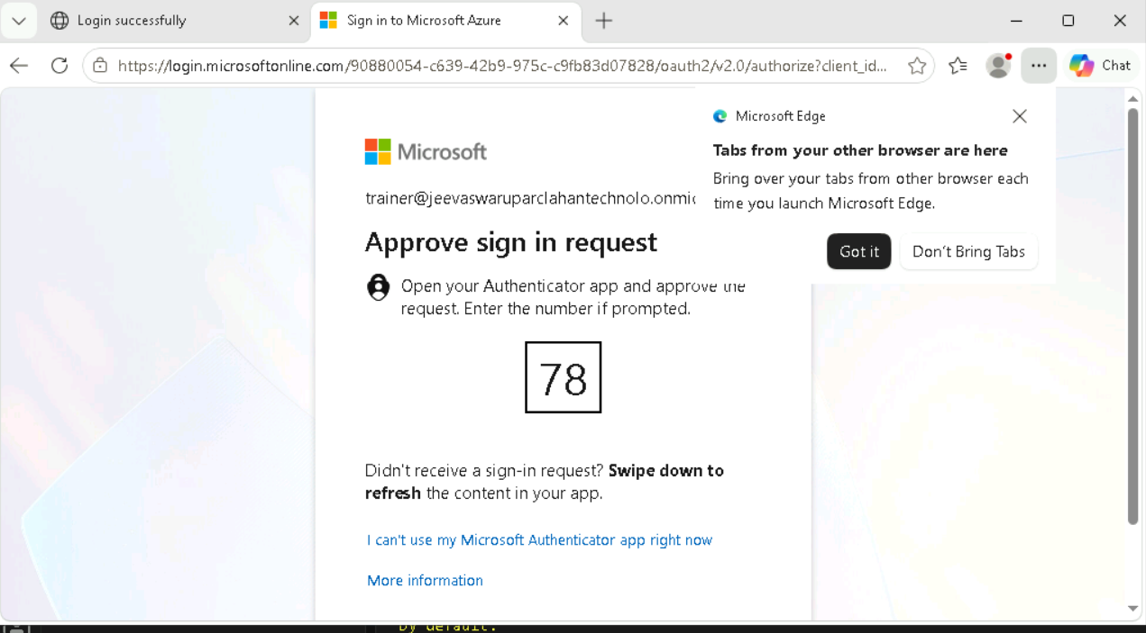
STEP7: enter this code in authenticator then u can signin.
